**Connecting with the Past – the Fundamental Principles of the International Red Cross Red Crescent Movement in Critical Historical Perspective**

**ICRC Humanitarium, Geneva**

**16-17 September 2015**

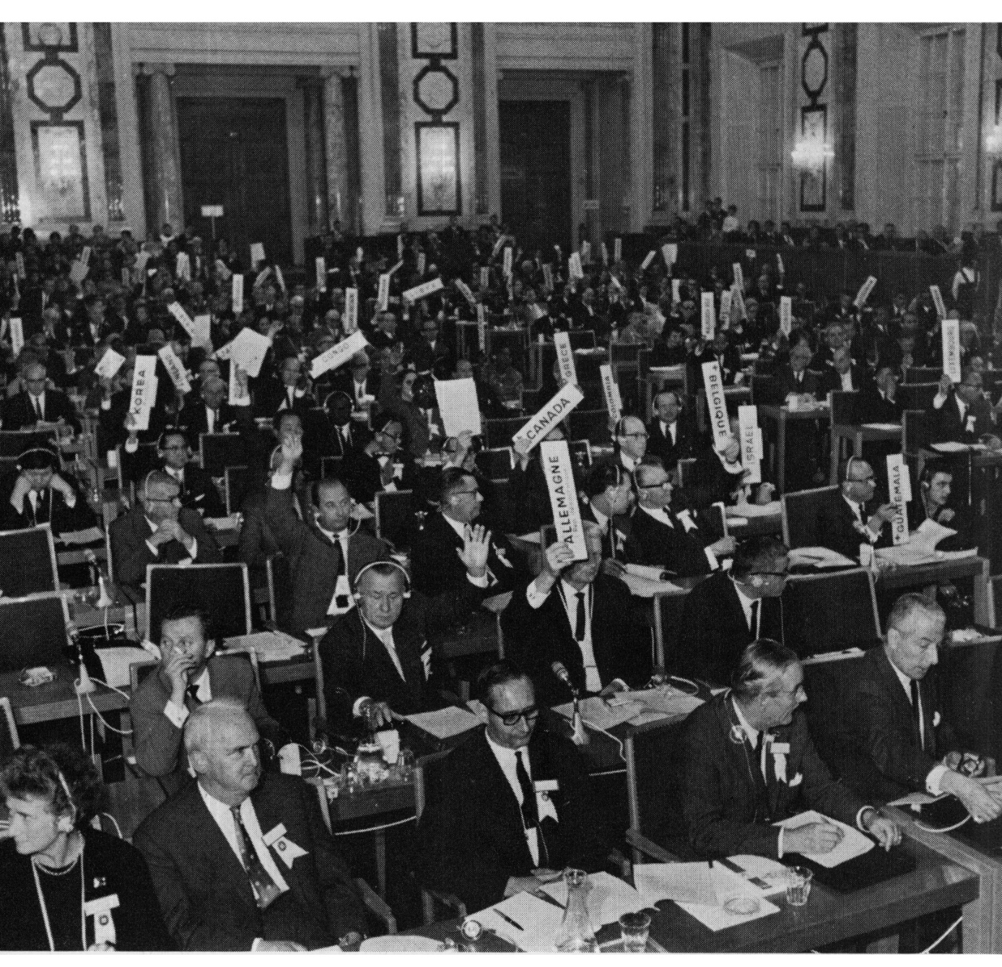

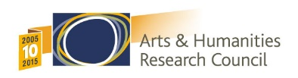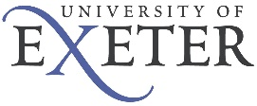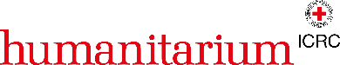

Workshop Schedule & NOte about filming at the conference 3

Location and directions 4

Room setting 6

Abstracts 7

Panel 1: The Birth of Modern Humanitarianism (1860s to First World War) 7

*Convenor: Dr Hugo Slim*

The Birth of Modern Humanitarianism: Perspectives from the Red Cross Society of China, 1899-1937 7

Dr Caroline Reeves, Associate in Research at the Harvard University Fairbank Center and Fundan University International Center for the Study of Chinese Civilization

The ICRC and the construction of neutrality before WWI 7

Prof Irène Herrmann, Associate Professor of Swiss Transnational History at the University of Geneva

The South African War as humanitarian crisis 8

Dr Elizabeth van Heyningen, Professor of History at the University of Cape Town

Panel 2: Consolidation and Expansion (from WWI to WW2) 8

*Convenor: Ms Nan Buzard*

When neutrality meets ideology: the ICRC in the Spanish Civil War 9

Mr Daniel Palmieri, Historical Research Officer at the Library and Public Archives Unit, ICRC

From imperial to political humanitarianism: Indian nationalist aid initiatives, 1914-1945 9

Dr Maria Framke, History Faculty at the University of Rostock

Quaker Relief between the two World Wars 10

Dr Daniel Roger Maul, Assistant Professor of History at Aarhus University

Panel 3: New Challenges (Decolonisation and the Cold War) 10

*Convenor: Prof. Yves Sandoz*

Humanitarian Principles Put to the Test. Challenges to Humanitarian Action During Decolonization. 10

Prof Andrew Thompson, Professor of Modern History at the University of Exeter

Caught in a trap: Neutrality, advocacy and the influence of the Third World on British and Irish NGOs, 1968-82 11

Dr Kevin O’Sullivan, Lecturer in History at theNational University of Ireland, Galway

Instrumentalization, mediatization and commoditization of aid 11

Dr Kamel Mohanna, Founder and Director of Amel Association, a non-sectarian Lebanese NGO

Panel 4: A ‘Golden Age’? (1980s and 1990s, including liberal interventionism) 12

*Convenor: Prof Sir Mike Aaronson*

Connecting with the Past: Context and Confluence 12

Dr Randolph Kent, Director of the Planning from the Futures Project, King’s College, London

Old wars, new wars and the (de) contraction of humanitarian space since the 1980s 12

Dr Marc-Antoine Pérouse de Montclos, Associate Fellow within the Africa Programme at Chatham House

Humanitarian Principles as factor of security? 13

Mr Michaël Neuman, Director of Studies at the Centre de réflexion sur l’action et les saviors humanitaires (Crash) of Médecins Sans Frontières

Recursive Humanitarianism: Enacting Humanitarian Principles in a Participatory Age 13

Dr Michal Givoni, Lecturer in Political Theory at Ben Gurion University

Panel 5: 9/11 and its Aftermath (operating in a newly constrained environment) 14

*Convenor: Mr Pascal Daudin*

The International Committee of the Red Cross in Afghanistan: reasserting the neutrality of humanitarian action 14

Dr Fiona Terry, Independent Consultant

Humanitarian Work After 911 14

Dr James Kisia, Executive Director ICHA and Deputy Secretary General of Kenya Red Cross

Who needs the humanitarian principles? 15

Dr Catherine Bragg, Deputy Emergency Relief Coordinator of OCHA 20008-2013, Adjunct Professor of Humanitarian Action, University College Dublin

Whither humanity in the quest for security? Humanitarianism in the post-9/11 Environment 15

Dr Larissa Fast, Fellow at the American Association for the Advancement of Science

TRANSLATION pANEL (no abstracts)

***Convenor: Mr Paul Castella***

*Panellists:*

*Kate Halff, Executive Secretary for the Steering Committee of Humanitarian Response (SCHR)*

*Prem Shankar Jha, Journalist and Author*

*Ingrid Macdonald, ‎Director Geneva & Humanitarian Policy at Norwegian Refugee Council*

*Hugo Slim, Head of Policy at the International Committee of the Red Cross*

ANNEX 1. Brief on Fundamental Principles for facilitators and speakers 17

annex 2. Public Event: Stubborn Realities, Shared Humanity: History in the Service of Humanitarian Action 20

ANNEX 3. Research & Debate Cycle on Principles Guiding Humanitarian Action 23

**ANNEX4. SPEAKER BIOGRAPHIES 25**

**ANNEX 5. PARTICIPANT BIOGRAPHIES 31**

**Please note: a copy of this programme, including participant bios, will be available during the conference at** <http://careforthefuture.exeter.ac.uk/events/>

# Workshop Schedule

|  |
| --- |
| Day 1 , 16th September 2015 |
| 08:30 – Doors open for registration (Humanitarium – tea and coffee available) |
| 09:00 – 09:15 Welcome & Introduction to the event |
| 09:15 – 10:45 Panel 1: The Birth of Modern Humanitarianism, 1860s to First World War |
| 10:45 – 11:15 Tea and coffee break (ICRC Restaurant) |
| 11:15 – 12.45 Panel 2: Consolidation and Expansion, from First World War to Second World War |
| 12:45 – 13:45 Lunch (ICRC Restaurant) |
| 13:45 – 15:15 Panel 3: New Challenges: Decolonisation and the Cold War |
| 15:15 – 18:00 Break (Optional visit to the Museum if you indicated you would like a ticket) |
| 18:00 – 19:30 Livestreamed public event |
| 19:30 – 21:00 Cocktail reception (ICRC Restaurant) |

|  |
| --- |
| Day 2, 17th September 2015 |
| 09:00 – Welcome coffee (Humanitarium) |
| 09:20 – 09:30 Welcome to Day 2 |
| 09:30 – 11:00 Panel 4: A “Golden Age”? The 1980s and the 1990s |
| 11:00 – 11:30 Tea and coffee break (ICRC Restaurant) |
| 11:30 – 13.00 Panel 5: 9/11 and its Aftermath: Operating in a Newly Constrained Environment |
| 13:00 – 14:00 Lunch (ICRC Restaurant) |
| 14:00 – 15:30 Concluding session: Translational Panel |

# Filming at the Conference

Please note that the UK *Arts and Humanities Research Council (AHRC) is working in partnership with the ICRC to produce a short film about the conference.  The film will consist of highlights from the conference and pre-organised interviews with Panellists including ICRC President, Peter Maurer. The purpose of the film is to take the Conference to as wide an audience as possible - across the Red Cross / Red Crescent Movement and beyond.

 A discreet camera / director production team will be present throughout the conference, during which they will be recording some very short vox-pop style interviews with delegates. If you wish to share your reflections on Fundamental Principles, or on the Conference itself for the purpose of the film, please feel free to make yourself know to the production team.

*The [Arts and Humanities Research Council (AHRC)](http://www.ahrc.ac.uk/) funds world-class research in a wide range of subjects: ancient history, modern dance, archaeology, digital content, philosophy, English literature, design, the creative and performing arts, and many more. Each year the AHRC spends approximately £98m to fund research and postgraduate training often in collaboration with partners. The quality and range of research supported by this investment of public funds provide considerable economic, social and cultural benefits to the UK.

*Please be aware not all interview footage will be used in the final edit.*

# Location and directions

International Committee of the Red Cross

19, Avenue de la Paix

1202 Geneva

Switzerland

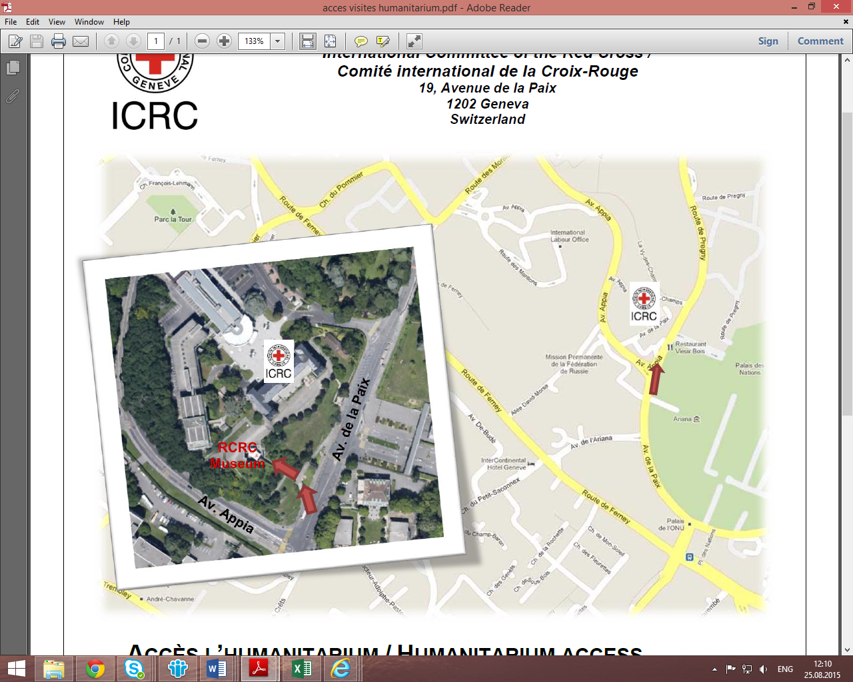

Please walk up to the Museum entrance on Avenue de la Paix 17

If driving, please park along Avenue de la Paix

**How to get to ICRC from Geneva Cornavin station by bus (8-12 min)**

* Bus **8** (towards OMS), **F** (towards Gex), **V** (towards Cs la becassiere) or **Z** (towards Bossy) - get off at stop **Appia.**
* If you are staying at a hotel, you will receive a free Geneva travel card that is valid for bus and tram transportation.
* Visit [www.tpg.ch](http://www.tpg.ch) for more information about public transportation. A regular ticket may be bought by texting TPG1 to the number 788.

# Room setting

For the workshop:

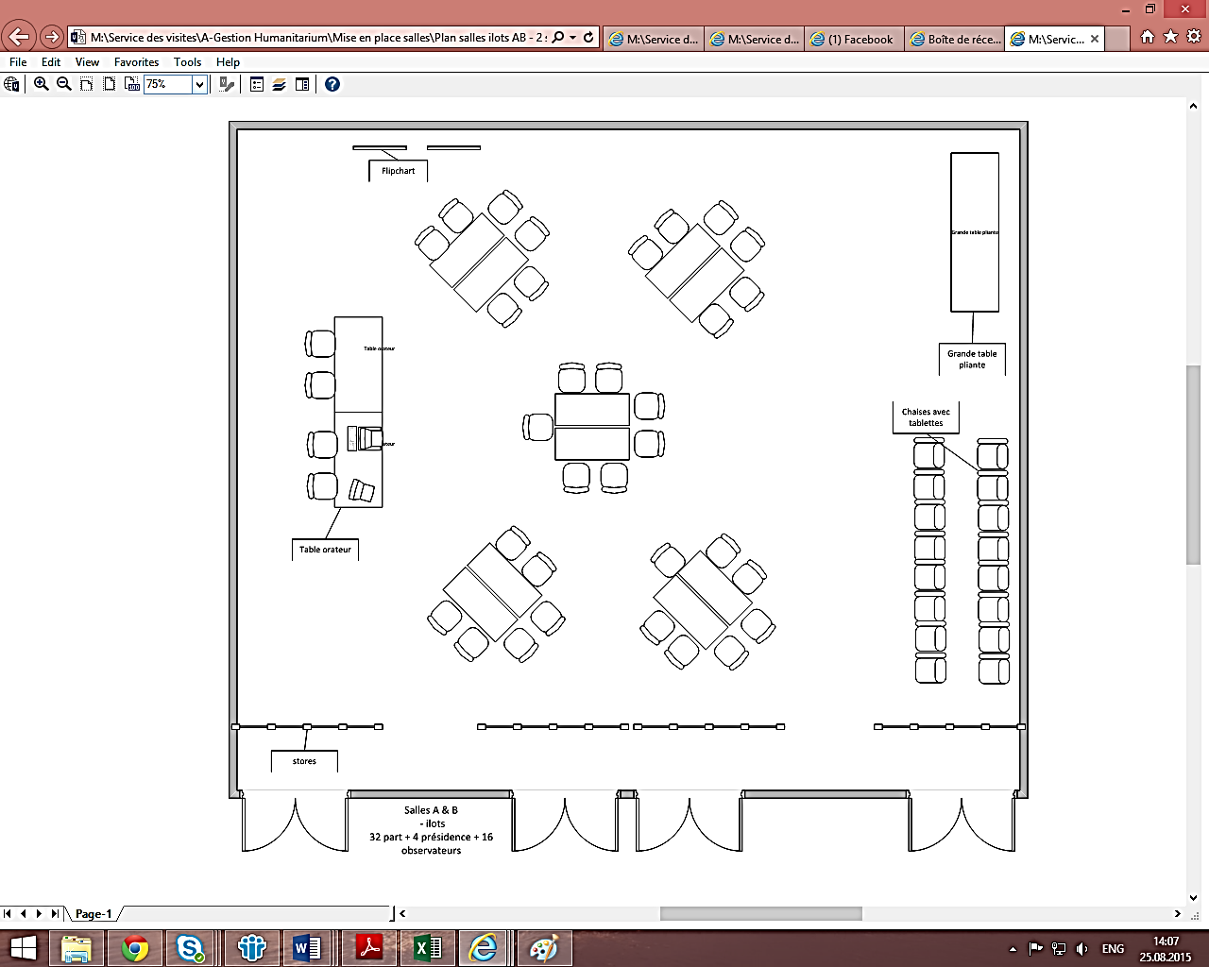

For the public event:



# Abstracts

## Panel 1: The Birth of Modern Humanitarianism (1860s to First World War)

16 Sept (9:15-10:45)

## *Convenor: Dr Hugo Slim*

### The Birth of Modern Humanitarianism: Perspectives from the Red Cross Society of China, 1899-1937

#### Dr Caroline Reeves, Associate in Research at the Harvard University Fairbank Center and Fudan University International Center for the Study of Chinese Civilization

The Red Cross Society of China was founded in 1904 by a group of Chinese elites intent on helping their countrymen trapped by the Russo-Japanese War in north China. But even before this date, the Red Cross movement was familiar to the imperial Chinese government and to a growing cadre of Chinese intellectuals, merchants and officials. How did the Chinese understand the Red Cross movement? How did they come to adopt a Western organization, permeated by principles and preoccupations foreign to China’s own cultural and material context?

This paper uncovers the original Chinese debates regarding China’s adherence to the Geneva Conventions and formation of a Red Cross Society sparked by the 1899 meeting at The Hague. These debates reveal important insights and correctives to the idea of “universality” in the Red Cross principles. It also discusses the remarkable growth of the Chinese Red Cross Society in the organization’s first 20 years of existence, examining how and why the Society was so successful in China during this period. Finally, I close by showing how the ICRC itself helped change the “independent” nature of the Chinese Society in the 1930s, injecting a Statist orientation into the management and direction of the national group, and setting the stage for a governmental take-over of the Red Cross Society of China even before the Communist revolution of 1949.

These revelations complicate the historical record/pedigree of the Red Cross movement’s “underlying principles” and show the importance of historical and cultural variability and evolution, even in the field of humanitarianism.

### The ICRC and the construction of neutrality before WWI

#### Prof. Irène Herrmann, Associate Professor of Swiss Transnational History at the University of Geneva

Neutrality is arguably one of the most famous and certainly one of the oldest principles of the Red Cross movement. This has long encouraged the belief that this principle has been both obvious and unvarying from the outset, a belief reinforced by its being identified with Swiss neutrality. Indeed, since the movement’s very beginning, most social actors have perceived a relation between the country’s and the institution’s neutrality.

However, at the time of the founding of the Red Cross, Swiss neutrality had not yet been clearly defined, while Red Cross humanitarians were still unsure about the concepts that might express their values and approach. So, far from being a static, self-evident concept, neutrality has constantly evolved.

This raises numerous significant questions. Why was neutrality considered an essential value for the Red Cross? What did it really mean in practice? How and why has this meaning changed? And, especially, how were these conceptual transformations related to Swiss neutrality?

At the end of the day, it would be worth determining not only to what extent Swiss neutrality influenced the construction of humanitarian neutrality but also to examine how the opposite may have operated as well. In other words, by analyzing the development of the principle of neutrality, the aim of this paper is to explore what might prove to be an early case of influence of humanitarianism on international values and principles.

### The South African War as humanitarian crisis

#### Dr Elizabeth van Heyningen, Professor of History at the University of Cape Town

The South African War (1899-1902) broke out at a point when two divergent processes were at work. One the one hand, military professionalization and the industrialisation of war contributed to an increase in violence, to ‘institutional extremism’, as one historian has described it. In a conflict that was approaching total war, civilians were targeted and managed to an extent that had rarely occurred before. On the other hand, humanitarian considerations had led to the Geneva Convention of 1864 and the Hague Convention of 1899, both of which attempted to regulate warfare. By 1899 there were Red Cross Societies both in Britain and in the Boer Republics. However, their contributions were confined to the military and were not extended to the civilian concentration camps that were established from about September 1900.

Nevertheless, the South African War was seen by many in Europe and the Americas as a moral issue, in which two small nations were defending themselves against greedy Imperial expansion. Above all, the treatment of white women and children became crucial to this critique. While the actions of Emily Hobhouse and the South African Women and Children Distress Fund are well known, similar organisations sprang into being throughout Europe. The Netherlands contributed a handful of invaluable nurses and substantial amounts of clothing were collected in such countries as France, Germany and Russia. These activities are relatively little known but are significant in that they allowed women, in particular, to contribute to the war effort. While little attempt has been made to demonstrate the continuities in humanitarian aid from South Africa at the beginning of the twentieth century, to the First World War, it seems likely that they did exist.

## Panel 2: Consolidation and Expansion (from WWI to WW2)

16 Sept (11:15-12:45)

## *Convenor: Ms Nan Buzard*

### When neutrality meets ideology: the ICRC in the Spanish Civil War

Mr Daniel Palmieri, Historical Research Officer at the Library and Public Archives Unit, International Committee of the Red Cross

### From imperial to political humanitarianism: Indian nationalist aid initiatives, 1914-1945

#### Dr Maria Framke, History Faculty at the University of Rostock

First Indian initiatives to provide humanitarian assistance during international conflicts date back to the late 19th and early 20th centuries. However, the scope of Indian aid and the multitude of humanitarian organisations broadened comprehensively during the First World War, when extensive initiatives emerged to help wounded military and civilian victims of the war in Europe, Asia and Africa. Although the Red Cross movement became active on the Indian subcontinent and for Indian victims during the Great War through the work of the British Red Cross Society as the Indian Red Cross Society would only be established in 1920, this presentation focuses on alternative relief activities organised by members of the Indian national movement.

Taking the First World War as a starting point, the presentation subsequently examines nationalist aid initiatives during the Spanish Civil War, the Second Sino-Japanese War and finally the Second World War. By looking at these cases, it investigates the motives and objectives of the Indian national movement to provide relief. The discourse on ‘humanity’ seems to have constituted a common thread amongst Indian nationalists; however, multiple shifting points of reference through which humanitarian relief was organized, for instance, ranging from empire to those of concurrent developments of internationalism and nationalism are also remarkable. Hence, the presentation asks how Indian nationalists conceptualized and implemented humanitarian aid and whether they discussed and followed common principles, such as impartiality, neutrality and independence. Finally, knowing that their work at times evolved within a wider Red Cross context, the question arises how this experience shaped the humanitarian work of the Indian nationalists?

### Quaker Relief between the two World Wars

#### Dr Daniel Roger Maul, Assistant Professor of History at Aarhus University

From their foundation during the First World War onwards Quaker relief organizations like the American Friends Service Committee (AFSC) and the British Friends Service Council played a significant role in many of the major humanitarian crises of the interwar years. Starting from this general observation my presentation will follow the history of Quaker aid along the major relief operations Friends’ service organizations became involved in throughout the period in question: From Germany/Austria (1920-1923) and Soviet Russia (1921-23), through the multi-faceted relief to the victims of Nazi persecution (1933-1940) and the Spanish Civil War (1936-1939) to the Second World War and its immediate aftermath. It will use the Quaker experience and put it in relationship to the wider developments of the relief sector during the interwar years, in order to gain insights both into the nature and evolution of humanitarian principles throughout the period. It will do so in particular by highlighting two basic tensions inherent to Quaker aid - firstly between the national and transnational/universal and secondly between humanitarian professionalism and a particular religiously founded ethics underlying Quaker relief.

## Panel 3: New Challenges (Decolonisation and the Cold War)

16 Sept (13:45-15:15)

## *Convenor: Prof. Yves Sandoz*

### Humanitarian Principles Put to the Test. Challenges to Humanitarian Action During Decolonization.

#### Prof. Andrew Thompson, Professor of Modern History at the University of Exeter

Abstract: my presentation will examine the meaning and purpose of the Fundamental Principles during and immediately after decolonisation. The end of empire was a period when the character of conflict experienced far-reaching changes, when the limitations of international humanitarian law were sharply exposed, and when humanitarian organisations of all kinds – the ICRC included – sought to redefine and expand their missions and mandates. The Fundamental Principles were caught up in these processes; subject to a resurgent state sovereignty, they were both animated and constrained by the three principal geopolitical forces of the era – decolonisation, the Cold War, and new and accelerating forms of globalisation. Particular attention will be paid to the politicization of the Fundamental Principles in the contexts of colonial counter-insurgency campaigns, the expansion of political detention under emergency legislation, and the transfers of power that saw the birth of newly-independent African and Asian states.

### Caught in a trap: Neutrality, advocacy and the influence of the Third World on British and Irish NGOs, 1968-82

#### Dr Kevin O’Sullivan, Lecturer in History at the National University of Ireland, Galway

The late 1960s and early 1970s witnessed the rapid growth of the global humanitarian sector, particularly among a newly resurgent community of NGOs. With it came challenges to the accepted boundaries of humanitarian relief. Tired of the traditional model of charity and neutrality, and far from convinced of its efficacy, from the mid-1960s a new generation of aid workers began to question the principles on which the humanitarian sector had hitherto been based, and to seek out a new approach, one rooted more in the principle of justice. The emergence of Médecins sans Frontières was the sector’s most visible response. But what impact did these trends have in the Anglophone world? To what extent was the expansion of the NGO sector influenced by discourses from the Third World? What kind of NGO community resulted? This paper explores the influence of Third World discourses of justice, rights, and revolution on NGOs in two Western European states: Britain and Ireland. I begin by exploring the influence of Third World thinkers on how NGOs understood ‘justice’ and its role in humanitarian aid. The second section of the paper then situates that narrative in its broader context, turning its emphasis to the importance of decolonisation and the impact that events in the Third World had on the way that NGOs practiced humanitarian aid. Finally, the paper turns back to the imperial paradigm to discuss some of the implications of this search for justice for how NGOs viewed and described the Third World, and the stools of independence and advocacy that those organisations often found themselves floundering between.

### Instrumentalization, mediatization and commoditization of aid

#### Dr Kamel Mohanna, Founder and Director of Amel Association, a non-sectarian Lebanese NGO

The process of decolonization structured the International Agenda, and had a strong impact on the development of NGOs. Northern NGOs supported the Southern ones created through the emergence of these new states. We observed at that time, how standards are opposed to field practices, and the principles are redefined by following the evolution of crises. During the period of the Cold War humanitarian crises have considerably evolved these principles. The external interventions have modified their applications. Just as the principle of sovereignty, that allows states to legitimize their policy by law and morality by going against humanitarian principles.

These changes highlight the internal crises. During this period, two principles have been pointed to: the instrumentalization of aid and the handling of it by the media. At this time the principles are observed through the terms of global poverty and unequal distribution of wealth. North / South relations are changing for those who take the dimension of the problem and are aware of its challenges. The seventies were the years where the growth of the NGO’s systems have evolved, restoring hope to the people facing the western domination, creating a space for discussion ( to the UN) and creating more justice and equitable relations. The principles are applied in the context of the confrontation of the Cold War in which an ideology has emerged. While assistance has become a "Business" and a "market", the commodification of aid satisfies the priority that donors provide way more than the support given to the beneficiaries. Furthermore, with more humanitarian interventions under the wing of military operations the basic principles of humanitarian action are misplaced. This capitalist shift undermined the principle of unity in the world where the dangers are numerous. How should we escape out of these traps and what lessons should we learn from our history to put these principles into action in the fairest manner possible, while wars are taking place in front of our eyes without us taking actions or reacting.

To answer that we offer three resolutions:

1. NGOs should be closer to the people, and don’t fall into the trap of assigning the role of the state.
2. We must also return to a regulatory state, a welfare state to guide us together towards one world and a common one future for a more just and equitable world in human relations.
3. Multiply the cooperation between northern and southern NGOs

## Panel 4: A ‘Golden Age’? (1980s and 1990s, including liberal interventionism)

17 Sept (9:30-11:00)

## *Convenor: Prof Sir Mike Aaronson*

### Connecting with the Past: Context and Confluence

#### Dr Randolph Kent, Director of the Planning from the Futures Project, King’s College, London

By the mid-1980s, ‘Cold War’ tensions between the ‘West’, led by the United States, and the Soviet Union and its allies, was beginning to lose momentum. While tensions still existed, that phase of post-World War II history seemed at the time to be at an end, and in various ways the ‘winners’ and ‘losers’ appeared to be increasingly evident. Clearly the emerging ‘winners’ were concentrated in the West, and those who now talked in terms of *glasnost* (openness) and *perestroika* (reorganisation) were not. In the context of the mid-1980s, this geopolitical transition significantly re-enforced Western assumptions about the dominance of its values, principles and capacities to influence.

This sense of dominance also was increasingly reflected in the ways that several key states in the West provided assistance. While a decade before, there was a degree of uncertainty about appropriate aid and delivery in crisis situations such as East Pakistan/Bangladesh, now in the mid-1980s geopolitical confidence spilled over into Western approaches to the provision of disaster and emergency assistance. The confluence between hegemonic power and humanitarian aid became ever more evident. In some very fundamental ways, they fed into each other when it came to approaches to assistance, relations with governments of the affected, donor perceptions of the affected and humanitarian principles.

This theme of confluence is intended to explain critical aspects of the humanitarian past, many of the frustrations of the present and perspectives on the future.

### Old wars, new wars and the (de) contraction of humanitarian space since the 1980s

#### Dr Marc-Antoine Pérouse de Montclos, Associate Fellow within the Africa Programme at Chatham House

This contribution will deconstruct the narratives of the so-called “new wars” and the perception of rising challenges for aid workers in situations of armed conflicts. Analysing the juncture between the 1980s and the 1990s, it will first remind us the difficulties of the cold war, when relief organizations had very little access to the Soviet bloc (Cambodia, Vietnam, Mozambique) or POWs camps in Iran, not even mentioning civilians in Southern Sudan or Somalia and attacks on humanitarian personnel in Salvador in 1984 or Pakistan and Afghanistan in 1989. The presentation will then introduce a general discussion on our perceptions of wars in developing countries: an over-politicization in the 1980s, as against their alleged criminalization in the 1990s.

### Humanitarian Principles as factor of security?

#### Mr Michaël Neuman, Director of Studies at the Centre de réflexion sur l’action et les saviors humanitaires (Crash) of Médecins Sans Frontières

Looking at MSF discourses and practices, the contribution will address the way the organization articulated the role of humanitarian principles with the management of the security of its projects. In particular, going back to the 1980s, it will try to illustrate how principles were in fact *not* a major component of concrete security management while IHL was seen as a tool to mobilize public opinions and States rather than a tool of negotiation. In particular, it will exemplify how practices of ‘embedment’ with armed groups were, throughout the 1980s, at the core of projects implementations in a number of countries.

### Recursive Humanitarianism: Enacting Humanitarian Principles in a Participatory Age

#### Dr Michal Givoni, Lecturer in Political Theory at Ben Gurion University

This paper will explore the notion of ‘recursive humanitarianism’; that is to say, the conviction that humanitarian practitioners must attend to the political conditions in which their actions unfold if principles such as neutrality and universality are to mean anything. By drawing on the practices of witnessing (*témoignage*) of Médecins sans Frontières in the 1980s and 1990s it will argue that the seeds of this reflexive consideration of humanitarian action and of its moral conditions of possibility were sown in that period. But it will further demonstrate that the active performance of humanitarian principles has only come to fruition in the 2000s with the rise of perceptions management as a new method for gaining acceptance for humanitarian interventions. Perceptions management relates to the relatively new interest of humanitarian organizations in the ways in which they are viewed by local stakeholders and to their attempt to act on and change these impressions. As I will argue, perceptions management now marks a new and important stage in the evolution of the humanitarian principles insofar as the enactment of these principles in the humanitarian theatres of operation has become such a critical issue.

## Panel 5: 9/11 and its Aftermath (operating in a newly constrained environment)

17 Sept (11:30-13:00)

## *Convenor: Mr Pascal Daudin*

### From ‘benign infidels’ to ‘agents of Western imperialism’: the changed perception of mainstream aid organizations.

#### Dr Fiona Terry, Independent Consultant

**Reflecting on aid operations in Somalia and Afghanistan since 2001, this contribution analyses some of the reasons for which humanitarian action has been rejected by belligerent groups and/or is considered a legitimate target of fraud and extortion. Can we blame it all on the global war on terror or do aid agencies share responsibility for the erosion of trust in their stated humanitarian commitments? Could a more genuine application of the principles of independence, impartiality and neutrality help to regain some lost trust?**

### Humanitarian Work After 911

#### Dr James Kisia, Executive Director ICHA and Deputy Secretary General of Kenya Red Cross

The humanitarian world was impacted by the unfortunate events of 911 terrorist attack on World Trade Centre in that it created hardline positions among some important player. On one side the western government saw the attack and many others around that time a threat to civilization, trust and democracy and by default there was the other group who were perceived to be the aggressor out to destroy a way of life for the civilized world. As a result of these events and the world view that followed there has been increased securitization of aid. This securitization is slowly moving humanitarian agenda from the humanitarian actors and into the hands of government and non-state parties in conflict. This has made it more challenging for humanitarian actor to enforce key normative elements of their mandate include the independence and impartiality. The challenges come from non-state and state actor in conflict where by the humanitarian actor have to prove the negative; that they are neither partial to the terrorist nor to the state. Putting altruism in question.

### Who needs the humanitarian principles?

#### Dr Catherine Bragg, Deputy Emergency Relief Coordinator of OCHA 20008-2013, Adjunct Professor of Humanitarian Action, University College Dublin

It is an oft-repeated mantra, not just in the Red Cross/Red Crescent Movement, but by other humanitarians, that adherence to the humanitarian principles is necessarily for acceptance, and acceptance is necessary for access. The mantra goes, without access, aid cannot reach those in need. The period following the turn of the Century (after 9/11) has been characterized by a proliferation of groups of actors involved in armed conflicts as well as groups of actors providing aid in conflict. Sometimes they are one and the same. Many of these (newer) actors, whether they are belligerents/conflict-aligned or not, have broader access to the crisis affected people than traditional "principled" humanitarian actors. If (more) aid is reaching those in need through these groups, then what is the value of the humanitarian principles? Who are the principles for?

It will be argued that the principles have been most relevant (1) in the self-identification of aid- providing entities, and not for evaluation of others, (2) for negotiation with the parties to the conflict, and (3) insufficiently for the crisis affected people.

### Whither humanity in the quest for security? Humanitarianism in the post-9/11 Environment

#### Dr Larissa Fast, Fellow at the American Association for the Advancement of Science

The post 9/11 environment and the politics of the “global war on terror” reshaped the operating environment and augmented the risks for individual aid workers and aid agencies. Where the politicization of aid characterized the 1990s, the “securitization of aid” dominated narratives of humanitarianism in the 2000s, particularly in explaining the increasing number of attacks against aid workers. Yet this type of exclusionary analysis promotes an image of humanitarians as exceptions, operating outside of the conflict dynamics that surround them, and as exceptional, part of a special category of civilians deserving attention and protection. These explanations serve to perpetuate the lauded role of aid actors in the public imagination and to maintain an analytical lens that preserves the *exceptionalism* of humanitarian actors.

Lost in the chaos of the post-9/11 context was the principle of humanity. Humanity is an essential and inspirational principle that affirms the inherent worth and dignity of the person. It insists upon respect for the person as well as the protection of life and health. In contrast, the implications of humanitarian exceptionalism are three-fold: as exceptions, aid actors are or should be immune from the violence within which they operate, while their exceptional nature creates hierarchies of ascribed internal (foreigner over national) and external (aid worker over other civilians) value that simultaneously privilege external threat as the primary cause of violence against them. The humanitarian exceptionalism narrative explains both the prevalence and the persistence of the political and securitized causal explanations, which in turn privilege security management responses based upon separation and fortification. While the politicization and securitization of assistance undoubtedly complicate access to vulnerable populations and compromise the safety and security of humanitarians, the risks are also ordinary, rooted in the routines of aid workers and agencies.

The future of humanitarianism must include renewed attention to the principle of humanity and the ways in which it manifests in the everyday actions of humanitarians. Indeed, much of what is now considered to be good and ethical practices, such as affirming local context and capacity, adopting vertical and horizontal accountability, and valuing proximity and presence, are rarely seen as manifestations of the principle of humanity. And they should be. Shifting the principle from the abstract to the concrete and everyday makes humanity tangible and, in the process, opens space to promote systemic and principled reform through a more inclusive vision of the humanitarian endeavour.

# **ANNEX 1. Brief on Fundamental Principles for facilitators and speakers**

***The following note aims to provide a brief introduction and description of the Fundamental Principles of the RCRC Movement, which will be at the core of the discussions at the conference.***

**The Fundamental Principles of Humanity, Impartiality, Neutrality, Independence, Voluntary Service, Unity and Universality were adopted at the XXth International Conference of the Red Cross and Red Crescent Movement in Vienna in 1965. They provide an ethical, operational and institutional framework guiding the work of the RCRC Movement, which was developed over a century of humanitarian action in the field.**

**In the words of Jean Pictet, a well-regarded ICRC jurist who theorized and commented the Principles, “the principles of the Red Cross do not all have the same importance. They have a hierarchical order [and] an internal logic, so that each one to a degree flows from another.”**

**Pictet distinguishes the “substantive” principles of Humanity and Impartiality, which belong to the domain of objectives, the “derived” principles of Neutrality and Independence, which are practical means – and not ends – to assure the confidence of all, and the “organic” principles of Voluntary Service, Unity, and Universality, which have an institutional character for the Red Cross and Red Crescent Movement (hereafter, the Movement).**

**The first four principles of humanity, impartiality, neutrality and independence have widely influenced the broader humanitarian community. They were later consecrated as the principles guiding humanitarian action through UN resolutions (UNGA resolution 46/182 of 1991) and the adoption of various codes of conducts and charters. However, these principles – especially neutrality – remain subject to differing interpretations, inconsistent application and, at times, outright rejection, which this conference proposes to explore.**

**Humanity**

*The International Red Cross and Red Crescent Movement, born of a desire to bring assistance without discrimination to the wounded on the battlefield, endeavours, in its international and national capacity, to prevent and alleviate human suffering wherever it may be found. Its purpose is to protect life and health and to ensure respect for the human being. It promotes mutual understanding, friendship, cooperation and lasting peace amongst all peoples.*

Humanity is the **essential** principle: the sole purpose of the Movement is to prevent and alleviate suffering, protect life and health, and ensure respect for the human being and, thus, without discrimination. Non-discrimination, usually associated with the principle of Impartiality, is part and parcel of the principle of Humanity.

Humanity is not only about bringing assistance to victims of conflicts or natural disasters, but also protection. There is a strong relational element in the principle of Humanity – encapsulated in the objective of ensuring “respect for the human being” – that requires to work in proximity to affected people.

**Impartiality**

*It makes no discrimination as to nationality, race, religious beliefs, class or political opinions. It endeavours to relieve the suffering of individuals, being guided solely by their needs, and to give priority to the most urgent cases of distress.*

The principle of Impartiality, which is recognized in International Humanitarian Law,[1] encompasses three sub-principles:

* **Non-discrimination**: aid should be delivered based on needs only, regardless of the nationality, religion, or political affiliation. This principle, which is implicit in the principle of Humanity, belongs to the domain of moral objectives.
* **Proportionality:** recognizing that humanitarian actors cannot meet all needs, the principle of proportionality enable humanitarian actors to distribute aid equitably, based on and in proportion to the priority and severity of needs. With this principle, we are entering in the domain of practical means. This also justifies that particularly vulnerable categories of people (e.g. women, children, people with disabilities, etc.) might require specific assistance and protection.
* **Exclusion of personal bias:** at an individuallevel, subjectivity and personal preferences must be put aside.

**Neutrality**

*In order to continue to enjoy the confidence of all, the Movement may not take sides in hostilities or engage at any time in controversies of a political, racial, religious or ideological nature.*

With the principle of Neutrality, we are firmly entering in the domain of means. Neutrality is a practical tool which primary objective is “to continue to enjoy the confidence of all”. Neutrality is about gaining trust and acceptance by parties to conflict, authorities, influential leaders and affected communities, which is essential to ensure safe access and deliver impartial aid.

The principle of Neutrality has different facets:

* **Military neutrality**: in a conflict or other situation of violence, not taking side or not acting in a way that could give an advantage to a party.
* **Ideological neutrality**:to avoid to engage in controversies of a political, religious or ideological nature that could antagonize some actors and undermine the acceptance of the organization.

**Independence**

*The Movement is independent. The National Societies, while auxiliaries in the humanitarian services of their governments and subject to the laws of their respective countries, must always maintain their autonomy so that they may be able at all times to act in accordance with the principles of the Movement.*

Independence is the corollary of Neutrality, and requires to be autonomous of the political or economic interest that any actor might have in a given context. Like Neutrality, it is an operational principle whose primary aim is to gain acceptance and to design programs that are solely based on an independent and objective assessment of needs.

Within the Movement, Independence refers also to the particular character of Red Cross and Red Crescent National Societies as auxiliaries to their public authorities in the humanitarian field. This specific status requires National Societies to entertain with their governments a balanced relationship that enables them to meet their responsibilities as auxiliary while maintaining some autonomy to act in accordance with the Fundamental Principles.

**Voluntary Service**

*It is a voluntary relief movement not prompted in any manner by desire for gain.*

Voluntary Service means that the Movement is not prompted by financial gain. It relates also to the very inception of the Movement, when Henry Dunant mobilized local communities in and around Solferino to come to the help of wounded soldiers.

Voluntary service is first and foremost an expression of solidarity with people affected by crises, driven by the principle of Humanity, but is also a token of independence. The local basis and anchoring provided by volunteers give to National Societies credibility and leverage to maintain some autonomy vis-à-vis their authorities.

**Unity**

*There can be only one Red Cross or one Red Crescent Society in any one country. It must be open to all. It must carry on its humanitarian work throughout its territory.*

The requirement that there is only one National Society per country, that it is open to all (i.e. recruit without discrimination) and that it covers its entire territory, is to be seen in relation with the principles of Impartiality, Independence and, to some extent, Neutrality.

Being the only National Society per country and covering the entirety of the territory, ideally with the presence of branches and volunteers, enables the NS to assess and address needs wherever they are and to be impartial at the national level.

Being open to all also guarantees that NS are a mirror of the demographic, social, economic and cultural reality of their country, which helps National Societies to gain respect and acceptance and to entertain the perception of an independent and neutral body. While important in peacetime, these requirements are all the more important in war time.

**Universality**

*The International Red Cross and Red Crescent Movement, in which all Societies have equal status and share equal responsibilities and duties in helping each other, is worldwide.*

For the Movement, Universality recovers both an institutional requirement and an aspiration. In order to deliver its mission in an impartial manner at the global level, the Movement must be present in every country (which is nearly a reality, given that there are currently 189 National Societies worldwide). It is also an aspiration since it reflects the belief that the “essential” principle of Humanity is truly a universal imperative.

Universality also has another facet, which is one of solidarity and complementarity between its members. It enables local action, through the network of volunteers and Red Cross / Red Crescent staff, to be strengthened and complemented when needed by the global solidarity network provided by the Movement. In conflict for instance, National Societies that have difficulties asserting their independence and neutrality vis-à-vis their government can benefit from the support and comparative advantages of the ICRC to enable a neutral and independent humanitarian action.

# **ANNEX 2. Public Event: Stubborn Realities, Shared Humanity: History in the Service of Humanitarian Action**

Geneva, 16 September 2015

**Background**

Over the past century and a half, the International Red Cross and Red Crescent Movement has spearheaded the elaboration and implementation of the principles guiding humanitarian action. Since they have been proclaimed nearly 50 years ago in Vienna, several of the Movement’s Fundamental Principles have been enshrined in UNGA Resolution 46/182 on the coordination of humanitarian assistance, as well as in State commitments and statements of numerous aid agencies. And yet, as ICRC President Peter Maurer [stated](http://www.youtube.com/watch?v=B0sX6bnb8NQ): “the concepts as well as practices of ‘Principled Humanitarian Action’ are increasingly being challenged in current conflicts.”

Trained as a historian, Maurer sees the ICRC’s long, rich and eventful past along as the history of the Red Cross Red Crescent Movement as a repository of experience with which to address the challenges of the twenty-first century. Of those challenges he has particularly picked out that of affirming and defining “through our action and cooperation with others what neutral, independent, and impartial humanitarian action is.”[2]

This panel discussion is the public segment of a two-day historical symposium. **"Connecting with the Past – the Fundamental Principles of the International Red Cross Red Crescent Movement in Critical Historical Perspective"** is jointly organized by the UK [Arts and Humanities Research Council](http://www.ahrc.ac.uk/Pages/Home.aspx), the [University of Exeter](http://humanities.exeter.ac.uk/history/research/centres/imperialandglobal/) and the [ICRC](https://www.icrc.org/eng/). The event is inscribed in the [***Research and Debate Cycle* *on Principles Guiding Humanitarian Action***](https://www.icrc.org/en/cycle-principles)*,* which aims at bringing the RCRC Movement to lead a global conversation on principled humanitarian action.

**Venue**

**Location:** Humanitarium, 19 Avenue de la Paix, CH 1202 Geneva.

**Time & Date:** 18:00-19:30 (followed by a cocktail reception), September 16th 2015.

**Room capacity**: 200

**Format:** *In situ* public conference + livestream ([publicly accessible](https://www.icrc.org/en/Fundamental-Principles-Historical-Perspective))

**Speakers**

**[Facilitator] *Vincent Bernard***, Editor-in-Chief of the International Review of the Red Cross, ICRC

**[Discussant 1] *Jane Cocking***, Humanitarian Director, OXFAM UK

**[Discussant 2] *Peter Maurer***, President of the ICRC

**[Beginnings - World Wars] *Irène Herrmann***, Associate Professor of Transnational History, University of Geneva

**[Decolonisation] *Andrew Thompson***, Professor of Modern History, University of Exeter

**[Liberal interventionism] *Michael Aaronson*** (Sir), Professorial Research Fellow, University of Surrey

**Objectives**

* While preserving the historical dimension of the two-day symposium, and by “tapping into the brainpower” of these panels, this livestreamed public event aims at producing a valuable additional output intended at a broader audience.
* To develop a refined understanding of the doctrine of humanitarian principles, in terms of both policy and practice, by setting the Fundamental Principles in critical historical perspective;
* More specifically, by taking a long view on the Principles:
  + to distinguish what is temporary and contingent from what is enduring and cumulative;
  + to understand the impact of different geopolitical environments on the Principles (including today’s geopolitics);
  + and by delving back into the past of the Principles to inform policy and practice today and critically reflect on the challenges they may face in their future;
* To gain a better understanding of alternative ideas and approaches regarding humanitarian principles and their application;

**Concept**

This public livestreamed conference is intended as an encounter between two humanitarian experts – i.e. ICRC President Peter Maurer and another Discussant – and three selected Representatives from panels of the two-day symposium. According to a determined periodization (see “Choreography” below), the Representatives take turn in presenting President Maurer and the Discussant with historical challenges to the Fundamental Principles, with the aim of reflecting on the evolution of these problematics to this day.

The conference opens with a general debate on Fundamental and Humanitarian Principles between Peter Maurer and the Discussant, under the oversight of a Facilitator. Following this exchange, the Representatives are invited by the Facilitator to come on stage on a turn-by-turn and chronological basis. They present the main problematic, conclusions and outcomes from their assigned panels.[3] More specifically:

* What were the most significant challenges to humanitarianism in the given historical period?
* Which Fundamental Principles were the most directly affected by these challenges?, or
* Which Fundamental Principles were the most crucial in responding to these challenges?

By injecting these elements into the discussion, the Representatives “provoke” Peter Maurer and the Discussant into eliciting their views regarding:

* the ways in which that problematic presented itself today;
* the reasons why it is still important;
* how it is being addressed;
* what scope was there to learn or draw insights from past experience in addressing it;
* whether the ICRC or other actors are in a better position to tackle the problematic now compared to previously (or conversely, whether it's become even more difficult, and if so why);

# **ANNEX 3. Research & Debate Cycle on Principles Guiding Humanitarian Action**

**Background**

Initiated in October 2014 by [President Maurer’s speech at the Maison de la Paix](https://www.icrc.org/en/document/webcast-peter-maurer-humanitarian-diplomacy-and-principled-humanitarian-action), this *Research and Debate Cycle* will take place throughout 2015 in Geneva, abroad and online, as a sequence of thematic events gathering key actors and experts from humanitarian practitioners, academics, governmental and military representatives, lawyers and policy-makers.

The rationale behind this conference cycle is to encourage the Movement and key partners to contribute to a global discussion on principled humanitarian action, over the course of a year marked by the 50th anniversary of the adoption of the Fundamental Principles and the 32nd International Conference of the Red Cross and Red Crescent Movement. While the Movement abides by its seven Fundamental Principles (FPs), humanitarian actors have endorsed some of them (in particular humanity, impartiality, independence and neutrality), frequently referred to as “humanitarian principles”. The conference cycle is meant as an open forum where Movement actors and others will discuss principles guiding humanitarian action at large (and not only the FPs).

**Objectives**

This *Research and Debate Cycle* aims to contribute to:

* Sharing and discussing the concrete **operational implications** of adhering to humanitarian principles in the field; debating the relevance of these principles today and exploring ways forward.
* In the run-up to the 2016 World Humanitarian Summit, **using the momentum** created by the 50th anniversary of the FPs and the 32nd International Conference to reflect upon and share the experience of the Movement in applying the Principles and strengthen its reputation as a reference on this topic.
* Bringing the ICRC and its partners among the Movement to serve as a **convener of a global conversation**, by promoting greater cross-sector exchanges on principled humanitarian action between academics, practitioners, governmental and military representatives, lawyers and policy-makers.

**Strategies**

The broad strategies employed for this *Research and Debate Cycle* are as follow:

1. **Research and Debate:** Gathering experts and informed participants in an open-minded environment where influential, dissenting, cutting-edge views are expressed, in order to present the latest state of the ongoing debate on principled humanitarian action. Hence the “Research & Debate” concept: to create a space where innovative research results and constructive debates are brought about.
2. **Dissemination:** Communicating the result of the debates to the public and relevant stakeholders, with a view to influence the larger debate on principled humanitarian action, to prepare the ground for the discussion on Fundamental Principles during the 32nd International Conference, and to help the Movement develop a unified position on this issue in the run-up to the World Humanitarian Summit.
3. **Operational relevance:** The debate on the humanitarian principles is a very pragmatic one: setting priorities in situations of overwhelming needs; fulfilling a commitment to humanity while taking into account the stark realities of power; and accessing populations in need while maintaining the safety of humanitarian personnel. The conference cycleaims to direct the events’ discussions toward a very concrete operational dimension, one that guides the daily and sometimes most crucial decisions of actors in the field.
4. **Overcoming the confusion around principles**. All events and communication material of the conference cycle will clarify the differences between the “Fundamental Principles” (i.e. the seven that were adopted by the Movement in 1965), the “humanitarian principles” (those that are widely recognized in the larger humanitarian community, e.g. in the UNGA Resolutions 46/182 and 58/114), and the “principles guiding humanitarian action” (in the largest sense, including proposals for new principles and dissident voices).
   1. **Fundamental Principles.** From an internal perspective, public debates on the FPs (among others) would contribute to a Movement-wide initiative to reinvigorate their understanding and application by RCRC actors. Externally, such events would inform the humanitarian community and the general public about the Movement’s distinctive identity and operational approach, which stems from these seven principles.
   2. **Humanitarian principles.** Enshrined in the practice of humanitarian actors whether or not a part of the Movement, the four principles of humanity, impartiality, neutrality and independence – generally referred to as the “humanitarian principles” (HPs) – provide the foundation for humanitarian action today. They are now being faced with misinterpretations, distortions, politicization and, sometimes, blatant rejection. Discussions on the HPs would be an opportunity to promote and strengthen the Movement’s distinct interpretation and understanding of these core principles, and their practical implications.
   3. **Principles guiding humanitarian action.** Far from a dogmatic exercise, this conference cycle is meant as an inclusive space that welcomes dissident voices and new ideas about principles at large. While RCRC actors will not be asked by the event organizers to either condone or endorse any of these views, these public debates will bring the Movement to engage with these “other principles”, and possibly to analyse and evaluate their relevance through the lenses of its own FPs.

# ANNEX 4. Speaker biographies

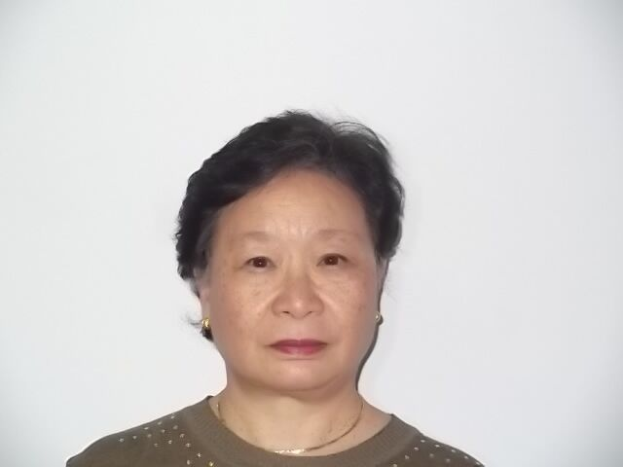**Catherine Bragg**

Dr. Catherine Bragg is an Adjunct Professor of Humanitarian Action at University College Dublin.  She retired two years ago from her position as UN Assistant Secretary-General for Humanitarian Affairs and Deputy Emergency Relief Coordinator, after serving five years.  Prior to her UN appointment, she served 24 years in the Government of Canada.  Her last Canadian post was as Director General of the International Humanitarian Assistance Program in the Canadian International Development Agency.  Dr. Bragg received her degrees from University of Toronto, University of Cambridge and the State University of New York at Albany.  A Canadian, she currently resides in Toronto.  She is married and has two children.

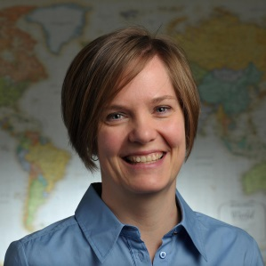**Larissa Fast**

Larissa Fast is a Science and Technology Policy Fellow with the American Association for the Advancement of Science (AAAS), working at the USAID Global Development Lab as Learning Lead for the Lab’s Ebola team. Dr. Fast is a scholar and practitioner, working at the intersection of research, policy, and practice related to humanitarianism, conflict, violence, and peacebuilding. She is an internationally-recognized expert on the causes of and responses to violence against conflict interveners, such as aid workers and peacebuilders, and has published extensively on the topic in both academic and policy-focused outlets. Her book, *Aid in Danger: The Perils and Promise of Humanitarianism* (2014, University of Pennsylvania Press) explores the causes of and responses to violence against aid workers. Dr. Fast has published in *Disasters*, the *European Journal of International Relations*, *Conflict Resolution Quarterly*, and other journals. Previously, she was Assistant Professor at the Kroc Institute, University of Notre Dame. She has consulted and worked for aid agencies and other international organizations, primarily in North America and Africa. Her research has been funded by the Swiss Development Corporation, the United States Institute of Peace, and USAID.

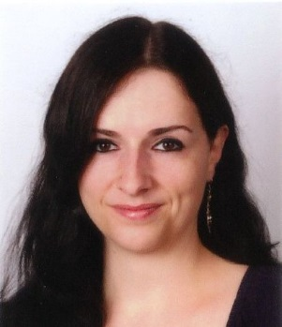**Maria Framke**

Dr. Maria Framke is a historian of modern South Asia, specifically focusing on the themes of history of politics, humanitarianism, international relations and ideologies. Her research interests include topics such as the fascism, colonialism and imperialism, ideas and knowledge transfer, and transnational history and humanitarianism. Maria is currently a lecturer in history at Rostock University, Germany. She is working on her habilitation project ‘South Asian humanitarianism in armed conflicts, 1899-1949’. Maria received her doctorate from Jacobs University Bremen in 2011 and did her Magister at Humboldt University Berlin, Freie Universität Berlin and SOAS, London. Her book on the *Engagement with Italian Fascism and German National Socialism in India, 1922-1939* was published in 2013 with the Wissenschaftliche Buchgesellschaft Darmstadt. T*ogether with Joel Glasman she has edited a special issue on ‘Humanitarianism’ in WerkstattGeschichte.*

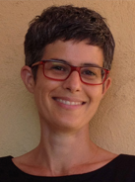**Michal Givoni**

Dr. Michal Givoni is an Assistant Professor in the department of Politics and Government at Ben Gurion University (Israel). She works in the field of contemporary political theory and studies the intersections of non-governmental politics and moral sensibility. Her work explores the history, ethics, and politics of humanitarian action; the ethics of witnessing and testimony; cosmopolitanism; and the politics of digital technologies of public participation. Some of her latest articles are: “Reluctant Cosmopolitanism: Perceptions Management and the Performance of Humanitarian Principles” (*Humanity,* forthcoming);“The Ethics of Witnessing and the Politics of the Governed” (*Theory, Culture & Society,* 2014);and “Humanitarian Governance and Ethical Cultivation: Médecins sans Frontières and the Advent of the Expert-Witness” (*Millennium*, 2011). Her book, *Ethical Witnessing: A History of a Problem* is forthcoming in Hebrew at the Van Leer Jerusalem Institute / Hakibutz Hame'uchad publishing house.

**Irène Herrmann**

Irène is Associate Professor of Swiss history at the University of Geneva (Switzerland). She studied Russian and history at the University of Geneva, where she obtained her PhD in history (1997). She then was visiting professor at the University Laval (Canada), lecturer at the Graduate Institute of International Studies (Geneva), fellow from the Swiss National Foundation at the Russian State University for Humanities (Moscow). Between 2005 and 2010, she was SNF Professor at the University of Fribourg (Switzerland). She has published more than 100 articles, several edited books and two monographs: Les cicatrices du passé. Essai sur la gestion des conflits en Suisse (1798-1918), Berlin, Berne, New York etc., Peter Lang, 2006; Genève entre république et canton. Les vicissitudes d'une intégration nationale (1814-1846), Geneva and Québec, Editions Passé-Présent and Presses de l'Université Laval, 2003. She also works on humanitarianism, conceptual history, conflict management and the political uses of the past in Switzerland and in Post-soviet Russia.

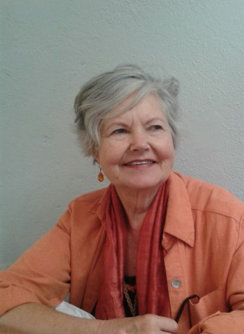**Elizabeth van Heyningen**

Elizabeth van Heyningenis an academic historian who taught for many years at the University of Cape Town. She is currently an Honorary Research Associate in the Department of Historical Studies. Her research interests include the history of Cape Town, the history of colonial women and the social history of medicine. Her recent book, *The Concentration Camps of the Anglo-Boer War. A Social History* (Auckland Park, Jacana, 2013), brings together several of these interests and was shortlisted for the Sunday Times Alan Paton prize in 2014*.* Amongst her publications are: *Cape Town. The Making of a City* and *Cape Town in the Twentieth Century* both with N. Worden and V. Bickford-Smith, and a variety of articles including a chapter on women in the siege of Mafeking.. Most recently she has become interested in the unpublished notebooks of Dr William Guybon Atherstone, a Grahamstown doctor and amateur geologist.

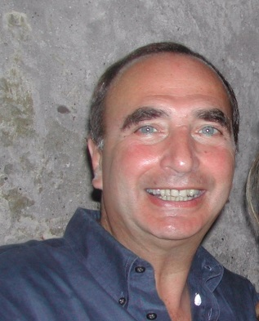**Randolph Kent**

Dr. Randolph Kent is the Director of the Planning from the Futures Project, a joint initiative with the Overseas Development Institute and Tufts University. Previously, he directed the Humanitarian Futures Programme at King’s College, London until 2014. The programme, established at the end of 2005, was designed to help enhance the adaptive and anticipatory capacities of humanitarian organizations to deal with the types of threats that need to be faced in the future.

He accepted his more recent posts after completing his assignment as UN Resident and Humanitarian Coordinator for Somalia in April 2002. Prior to his assignment in Somalia, he served as UN Humanitarian Coordinator in Kosovo [1999], UN Humanitarian Coordinator in Rwanda [1994-1995], Chief of the IASC’s Inter-Agency Support Unit [1992-1994], Chief of the UN Emergency Unit in Sudan [1989-1991] and Chief of Emergency Prevention and Preparedness in Ethiopia [1987-1989].

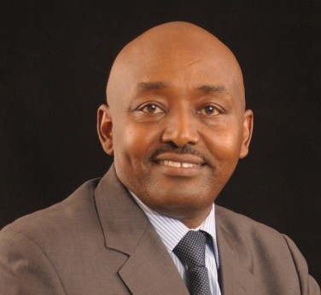**James Kisia**

Dr. James Kisia is the Executive Director for the International Centre for Humanitarian Affairs and Deputy Secretary General, Kenya Red Cross. He has over sixteen year experience in humanitarian work at senior management level. Prior to joining the Kenya Red Cross ten years ago James has worked for the government of Kenya as medical officer in disaster and conflict prone areas of northern Kenya. At Kenya Red Cross James has held the positions of Head of Health, Deputy Secretary General and Head of Operations. He has served in global committees in health, DM and other Movement initiatives. He is currently a thematic lead for the East and Southern Africa World Humanitarian Summit consultation and has written on humanitarian matters as well as presented papers on emergency health, disaster management, and humanitarian funding in global workshops.

James trained as Medical Doctor in the West Indies later received his MSc in Public Health from the London School of Hygiene and Tropical Medicine. He also hold an MA (Distinction) in practicing management from Lancaster University Management School.

James lives in Nairobi with his wife and two sons.

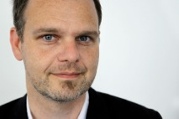**Daniel Roger Maul**

Daniel Roger Maul is an Assistant Professor of History at Aarhus University/Denmark. His main research interest is in the history of 20th century humanitarianism, in the history of globalization and international organizations. Since 2010 he has been leading a research project on “Global Aid – American NGOs and the emergence of international relief 1890-2010” funded by the German Volkswagen Foundation.   Maul has widely published on the history of the International Labour Organization. His most important publication in this field is *Human Rights, Development and Decolonization: The ILO 1940-1970*(Palgrave Macmillan 2012). He is currently working on a book on *American Quaker Relief 1890-1950*.

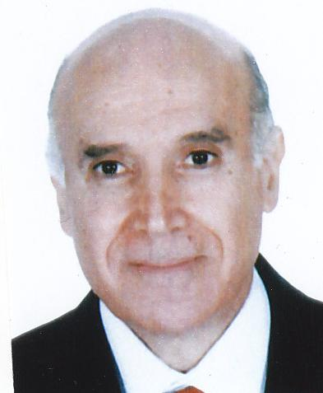**Kamel Mohanna**

Born in 1943 the year of the independence of Lebanon in Khyam, a village in southern Lebanon, Dr. Kamel Mohanna studied at the time of illiteracy, defying poverty to become a doctor. He built a Lebanese role by engaging in the student’s movement which in the sixties lifted France. Then in the seventies, following the path of Che Guevara, he joined the revolutionaries in the mountains of Dhofar. It is there where he participated in the march of the "barefoot doctors" in the footsteps of Mao.

He resisted the lure of Paris, Canada and the luxurious neighborhoods of Beirut as he preferred on his return to Lebanon the misery of the Palestinian refugee camps where he lived with the poor and the sick people which he made his case. In the civil war in the seventies and eighties, he roamed Lebanon, not hesitating to go against all the commonly accepted political parties. In 1979 in the war time he created Amel, open to all partition time, preaching life in the shadow of a collective suicide. Until today and through this non-denominational organization, Dr. Kamel continue working to develop the humanity of the human being, regardless of his religious, political and geographic belonging trying to create a dignified world. Kamel Mohanna is now president of Amel International Association and General Coordinator of the group of “Lebanese and Arab NGOs”. He is also a pediatrician and a professor at the Lebanese University.

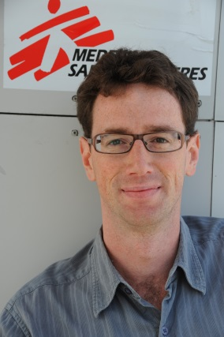**Michaël Neuman**

A director of studies at the MSF – Crash (Centre de réflexion sur l’action et les savoirs humanitaires) since 2010, Michaël Neuman holds a Masters degree in contemporary history and international relations from Université Paris 1. He joined Médecins Sans Frontières in 1999, alternating between missions in the field (the Balkans, the Caucasus and West Africa) and positions at MSF headquarters (in New York and Paris as deputy program manager). His work has also addressed political analysis and issues of immigration and geopolitics. From 2008-2010, Neuman served on the board of directors of the French and US sections of MSF. Among other works, he is the co-editor of “Humanitarian Negotiations revealed, the MSF experience”, Hurst and Co, 2012. At the MSF-Crash, his current work aimed at discussing the professionalization of security management within the humanitarian sector and MSF.

**Daniel Palmieri**

Daniel Palmieri joined the International Committee of the Red Cross (ICRC) in 1994 and, since 2002, he has been Historical Research Officer at the Library and Public Archives Unit. His research is based on the history of the ICRC and more generally on humanitarian actions in wartime and on the history of armed conflicts. He belongs to several historical scientific committees, including that of the Rivesaltes Memorial. He is also co-founder of the History of International Organizations Network (HION) which gathers some 250 specialists worldwide on the history of international organisations.

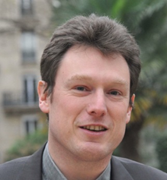**Marc-Antoine Pérouse de Montclos**

Marc-Antoine Pérouse de Montclos is a Doctor in political science and a Professor at the French Institute of Geopolitics in the University of Paris 8. A specialist on armed conflicts and humanitarian aid in Africa South of the Sahara, he graduated from the Institut d’études politiques in Paris (IEP), where he teaches, and is an Associate Fellow at the Africa Programme, Chatham House (London), and PRIO (Peace Research Institute in Oslo). He lived during several years in Nigeria, South Africa and Kenya. A researcher at the Institut de recherche pour le développement (IRD), he published some eighty articles and books, including *Le Nigeria* (1994), *Violence et sécurité urbaines* (1997), *L’aide humanitaire, aide à la guerre ?* (2001), *Villes et violences en Afrique subsaharienne* (2002), *Diaspora et terrorisme* (2003), *Guerres d’aujourd’hui* (2007), *Etats faibles et sécurité privée en Afrique noire*(2008), *Les humanitaires dans la guerre* (2013), *La tragédie malienne* (2013), *Crises et migrations* (2014), and *Boko Haram: Islamism, Politics, Security, and the State in Nigeria* (2015).

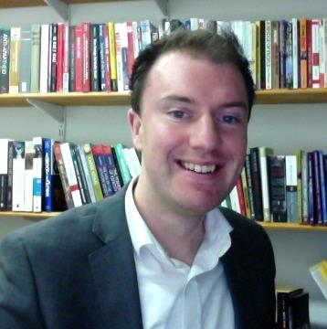**Kevin O’Sullivan**

Kevin O’Sullivan is a lecturer in history at National University of Ireland, Galway, and an honorary research fellow at the University of Birmingham. His main research interests are in international history, particularly the areas of globalisation, decolonisation, humanitarianism, and NGOs. Kevin’s first book, *Ireland, Africa and the end of empire: small state identity in the Cold War, 1955-75*, was published in 2012 by Manchester University Press, and he has written most recently in *Humanity*, the *Journal of Genocide Research*, and in a collection of essays on *International Organisations and Development, 1945-1990* (Palgrave Macmillan, 2014). His current project, titled ‘The NGO Moment: The Globalisation of Humanitarianism in Ireland, Britain, and Canada, 1968-85’, examines the social and political phenomena that inspired the rapid expansion of the global NGO sector in that period. As part of that work, Kevin co-organises the Non-State Humanitarianism international research network that brings together academics and members of the humanitarian sector (funded by the British Arts and Humanities Research Council, and the Irish Research Council; <http://nonstatehumanitarianism.com/>).

**Caroline Reeves**

Caroline Reeves is an Associate in Research at Harvard University’s Fairbank Center, specializing in the history of Chinese charity and philanthropy. Since 1990, she has studied early-20th-century transnational processes including the global spread of international humanitarian norms. Reeves received her BA and her PhD from Harvard in History and East Asian Languages, as well as studying Chinese Foreign Relations at Langues Orientales at the Université de Paris. She has conducted research in Beijing, Shanghai, Nanjing, Taipei, Geneva, Oxford, and Washington DC and taught at Harvard University, Williams College, Emmanuel College and on Semester at Sea. Recently awarded an ACLS grant to develop a project on the Social Lives of Dead Bodies in Modern China, she has just completed a study of the introduction of humanitarian photography in China. A visiting scholar at Fudan University in Shanghai, she is now working on a manuscript on the history of Chinese philanthropy and its import in the contemporary global arena.

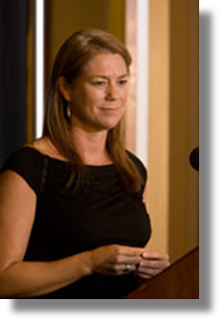**Fiona Terry**

Fiona Terry has spent most of the last 20 years involved in humanitarian operations in different parts of the world including Northern Iraq, Somalia, the Great Lakes region of Africa, Liberia, Sudan and Myanmar. She worked for a decade with MSF, both in the field and in Paris headquarters, before working for several years with the International Committee of the Red Cross.

Terry holds a Ph.D. in international relations and political science from the Australian National University and is the author of Condemned to Repeat? The Paradox of Humanitarian Action (Cornell University Press, 2002), which won the 2006 Grawemeyer Award for Ideas Improving World Order. As an independent researcher, she has undertaken several in-depth studies for the ICRC including on the practice of neutrality in Sudan and Afghanistan, and on violations of the protected status of health care in conflicts around the world. She is a member of the editorial committee of the International Review of the Red Cross.

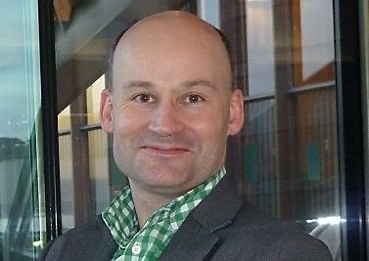**Andrew Thompson**

Andrew Thompson is Professor of Modern History at the University of Exeter, and the Director of the Exeter Centre for Global and Imperial History. He has published widely on the history of empire during the nineteenth century. His books include: *The Empire Strikes Back? The Impact of Imperialism on Britain from the mid-nineteenth century* (2005); *Empire and Globalisation. Networks of People, Goods and Capital in the British World, c.1850-1914* (2010); *Britain’s Experience of Empire during the Twentieth Century* (2012); and *Writing Imperial Histories* (2013). He is a Council Member and Executive Advisor to the UK’s Arts and Humanities Research Council, and leads a multi-disciplinary national programme of research, *Care for the Future: Thinking Forward through the Past*, which explores the relationship between the past, present and future and how that relationship shapes our understanding of the world around us. He is currently writing a history of the international humanitarian system after the Second World War entitled: *Humanitarianism on Trial. How a Global System of Aid and Development emerged through the End of Empire*.

# ANNEX 5. Participant biographies*

*Please note that the following are biographies received in advance of our printing deadline. For the complete list of biographies, please visit <http://careforthefuture.exeter.ac.uk/events/>.

**Dr Caroline Abu Sa'Da** is Director of the Research Unit of MSF Switzerland. She holds a doctorate in Political Science and International Relations from Sciences Po, Paris. She has worked on food security and has coordinated programs in the field, notably in the Middle East, for Oxfam GB, the United Nations and MSF Switzerland. Dr Abu-Sada is the author of "ONG palestiniennes et construction étatique, l’expérience de Palestinian Agricultural Relief Committees (PARC) dans les Territoires occupés palestiniens, 1983- 2005", "In the Eyes of Others. How People in Crises Perceive Humanitarian Aid", "Le développement, une affaire d'ONG? Associations, Etats et Bailleurs dans le monde arabe”, “Dilemmas, Challenges, and Ethics of Humanitarian Action”, Mc Gill-Queen's University Press, 2012. She has also written numerous papers, reports and chapters on humanitarian action, NGOs and the Middle East, and has taught political science at New York University, Paris and at Sciences Po, Lille. Her latest publications are Abu Sa’Da, Duroch, Taithe, « Attacks on medical missions: overview of a polymorphous reality: the case of Médecins Sans Frontières », International Review of the Red Cross, 95 :889, 2014 and « L’urgence d’une souveraineté alimentaire », in Rony Brauman’s Manifeste pour les Palestiniens, Paris, Editions Autrement, October 2014.

**Dr Jose A. Bastos**, Medical Doctor, MPH. Medical humaritarian field work (Iraq-Turkey 91, Kenya 92, Angola 93, Somalia and Rwanda-Tanzania 94, Kivu 96-97, Angola 99) and management with MSF (Emergency Unit MSF-Spain 95-96, Ops Director MSF-Spain 97-98, Ops Director MSF Holland 2000-04). After a gap doing clinical medical work in Australia (2004-07), worked with the ICRC (Pakistan 2007-08, Project Coordinator; Iraq 2008-09, Detention Doctor; Afghanistan 2009-10, Medical Coordinator). Since end 2010 till today is the President of MSF Spain.

**Dr Jean-Luc Blondel** (1953, Swiss), Dr theol. ICRC delegate since 1982: various field missions (in particular: El Salvador, Jerusalem, Buenos Aires) and responsibilities at the ICRC headquarters (Head of Policy and cooperation within Red Cross and Red Crescent Movement; Personal advisor to the President and Secretary of the ICRC Assembly; Head of Archives). Director of the International Tracing Service (Bad Arolsen, Germany, 2009-2012). Currently Advisor (historical research) in the ICRC Department of Communication and Information management.

**Ms Rebecca Dodd** is the Senior Officer for Fundamental Principles at the International Federation of Red Cross and Red Crescent Societies. Rebecca joined the Movement in 1997 and since then has worked for the IHL Department of Australian Red Cross has also undertaken field missions with the ICRC. She is a lawyer by way of background, having practiced in the areas of criminal law, child protection and mental health.

**Ms Sherine El Taraboulsi** is a Research Fellow with the Humanitarian Policy Group at the Overseas Development Institute in London. She is also reading for a DPhil (PhD) in International Development at University of Oxford. She has more than ten years of experience running projects that link research to policy and practice within the MENA region and Africa. Her current theoretical interests are on state formation and ethnic identity. Her other research interests include: humanitarian action, post-conflict reconstruction as well as radicalization and youth. Her research has covered Libya, Tunisia, Egypt, Yemen and North Nigeria with an interest in state and nation formation, the influence of socio-political transitions on resource mobilization and formal and informal types of youth civic engagement. Her thesis is a socio-historical analysis of the role of non-state actors in state formation in divided societies with a focus on Libya (1939 – 1970)."

**Mr Thierry Germond** Born in 1947, Thierry Germond studied social work at the Lausanne School of Social Studies. Joined the ICRC for a first mission in Biafra in 1969 until the end of the Nigeria/Biafra conflict in January 1970. After successive missions in Bangladesh, Cyprus and Angola from 1973 to 1976, he was in charge of Angola, Mozambique and relations with the Liberation Movements of Southern Africa (ZANU-PF and SWAPO) from 1976 to 1980. After two years as Head of Mission in Hanoï (Vietnam), he was in charge of the Eastern Europe's desk until 1985. From 1985 to 1989 he had the desk in charge of the ICRC Regional delegations in Africa. As Delegate general for Europe from April 1989 to end of 1994, he dealt with the fast changing situation in Europe and notably the events following the fall of the regime in Rumania and the conflicts in former Yugoslavia. After three years dealing with the relations within the Red Cross Movement, he was appointed Head of Mission in Brussels in 1997, in charge of the relations with the European Union, NATO and the NATO Parliamentary Assembly. Following his retirement in 2004, he still made a temporary mission in Pyongyang (North Korea) and was given some assignments in regard of the ICRC Archives.

**Ms Kate Halff** Since May 2013 Kate Halff has been working as Executive Secretary for the Steering Committee of Humanitarian Response (SCHR), an alliance of seven NGO networks and the Red Cross / Red Crescent . She took on this position after having been the Director of the Norwegian Refugee Council’s Geneva-based Internal Displacement Monitoring Centre (IDMC). Prior to these positions, Kate Halff worked for over 10 years in humanitarian leadership positions in East Africa, as Country Director for Action Contre la Faim, Oxfam and Save the Children, and as Humanitarian Affairs Officer for UN - OCHA. Kate Halff holds two Master degrees from Paris 3-Sorbonne in International Relations and in Development studies. She is married with two children.

**Prof Matthew Hilton** is Professor of Social History at the University of Birmingham. His most recent books are Prosperity for All: Consumer Activism in an Era of Globalisation (Cornell, 2009) and, with James McKay, Nicholas Crowson and Jean-François Mouhot, The Politics of Expertise: How NGOs Shaped Modern Britain (Oxford, 2013). He has co-edited several collections of essays, including The Ages of Voluntarism (OUP, 2011) and Transnationalism and Contemporary Global History (P&P/OUP, 2013). He is editor of Past and Present and is currently engaged on a history of British approaches to humanitarianism.

**Mr Prem Shankar Jha** has been the Economic Editor of the Times of India, the Editor of the Financial Express and the Hindustan Times, and the media adviser to Prime minister V.P. Singh in 1989-90. He has been a visiting scholar at Nuffield College Oxford (1976-77); Weatherhead Centre for International Studies, Harvard (1995) and the Fairbank Center for East Asian Research ,Harvard (2006-7). He was a Visiting Professor at the University of Virginia(1997-2000) and the first holder of the chair on the Indian Economy at Sciences-Po in Paris in 2007-8. His books include India- A Political Economy of Stagnation -1980;   
Twilight of the Nation State-- Globalisation Chaos and War, Sage/ Pluto 2006.  
Crouching Dragon, Hidden Tiger: Can China and India dominate the West. Softskull US and UK, 2010, and Penguin India , 2010.

**Mr Georges Kettaneh**, Secretary General of the Lebanese Red Cross Society. Director of the Emergency Medical Services in the Lebanese Red Cross from 1992 to 2005 during which he built up the ambulance network in Lebanon and established the national medical emergency hotline "140". Established the Disaster Management Unit in LRC and became National Director of Operations in the Lebanese Red Cross in 2005 in charge of 4000 volunteers and 180 staff performing ambulance services, disaster response, blood services and medico-social services. Appointed Secretary General of the Lebanese Red Cross in March 2013, became responsible for developing and implementing the LRC's long-term development strategy and overseeing response to the Syria refugee crisis.   
Member of several key national committees and working groups including   
Project Board of UNDP’s Supporting Prime Minister’s Office for Strengthening Disaster Risk Management Capacities in Lebanon; the Government National Committee for Emergency & first aid in Road accidents; and the Arab RCRC for Regional Contingency Plan.

**Dr Fabian Klose** (Leibniz Institute of European History Mainz, Germany)  
Fabian Klose received a Ph.D. degree in Modern History from the LMU Munich in 2007. From 2008 to 2009 he was Lecturer at Princeton University and from 2009 to 2012 Senior Researcher at the LMU Munich. Since November 2012 he is Senior Researcher at the Leibniz Institute of European History (IEG) in Mainz. His research focuses on the history of decolonization, international humanitarian law, human rights, and humanitarianism in the 19th and 20th centuries. He has recently published his book Human Rights in the Shadow of Colonial Violence: The Wars of Independence in Kenya and Algeria (University of Pennsylvania Press, 2013). He is currently working on his new project about humanitarian intervention in the long 19th century. His edited volume The Emergence of Humanitarian Intervention: Ideas and Practice from the Nineteenth Century to the Present is forthcoming in November 2015 (by Cambridge University Press). He is Editor (together with Johannes Paulmann) of the blog Humanitarianism & Human Rights http://hhr.hypotheses.org/ and Academy Leader (together with Johannes Paulmann and Andrew Thompson) of the Global Humanitarianism Research Academy (GHRA).

**Ms Ingrid Macdonald** is currently the director of NRC Geneva and Humanitarian Policy, where she leads the organisation’s engagement with the UN and IASC, as well as NRC’s humanitarian policy portfolio. Ms Macdonald is the Co-Chair of the IASC Task Team on Revitalizing principled humanitarian action, as well as a member of the Senior Transformative agenda Implementation Team (STAIT), and a member of the Humanitarian Programme Cycle Steering Group. She has participated in the Operational Peer Review to South Sudan and the Philippines. Ms. Macdonald was previously NRC’s Head of Advocacy, and based in Kabul from 2007 to 2009 as Regional Protection and Advocacy Manager for Afghanistan, Pakistan and Iran. In Kabul, she was an NGO representative to the HCT, deputy-Chair of the Afghanistan National Protection Cluster, and an NGO representative of the National Civil Military Working Group Steering Committee. Prior to NRC, Ms. Macdonald was Oxfam’s Policy lead in Sudan and the Solomon Islands, as well as their Mining Ombudsman from 2001 to 2005 where she led investigations and conflict resolution process covering community grievances with mining companies in Peru, Indonesia, Papua New Guinea, the Philippines, Indonesia Islands and Fiji. She has also worked extensively with the International Women and Mining network on indigenous women’s rights and labour concerns. Outside the NGO sector, Ms. Macdonald was a management consultant in Australia and Deputy Director with the Land and Facilities Management Directorate of the New Zealand Defence Force in the late 1990s. Ms. Macdonald has post-graduate qualifications in International Law and degrees in Geography/Politics. She is widely published in areas such as corporate social responsibility, humanitarian access, protection and displacement and civil military relations.

**Prof Johannes Paulmann** is Director of the Leibniz Institute of European History (IEG) at Mainz. His research interests cover European and International History. His prize-winning Pomp und Politik (Paderborn 2000) deals with royal and state visits in Europe from the Ancien Régime to the First World War. He co-edited (with Martin H. Geyer) The Mechanics of Internationalism: Culture, Society and Politics from the 1840s to the First World War (Oxford 2001). He recently published ‘Conjunctures in the history of international humanitarian aid during the twentieth century’, Humanity 4/2 (2013) and co-edits (with Fabian Klose) the blog Humanitarianism & Human Rights http://hhr.hypotheses.org/ The edited volume The Dilemmas of Humanitarian Aid in the Twentieth Century is forthcoming with Oxford University Press in 2016.

**Dr Tanja Schuemer** is a humanitarian affairs officer in the Inter Agency Standing Committee (IASC) Secretariat. Her career spans over 16 years in humanitarian contexts at HQ and field levels in complex emergencies. Before joining the IASC Secretariat, Tanja was the Director of the Somalia NGO Consortium, a network of over 90 local and international NGOs delivering humanitarian and development assistance across Somalia. She has previously worked for the UK Department of International Development in London and Sudan, the European Union and several international NGOs including Oxfam and CARE. Tanja has extensive experience in coordination, advocacy, policy analysis and strategic planning, and operational management. Tanja’s geographic experience includes Georgia, Sri Lanka, Sudan, Somalia, Sierra Leone, Kenya and Guyana, amongst others. Tanja holds a PhD from the Department of War Studies at King’s College London, where her thesis examined the UK’s New Humanitarian Policy and its application in Sierra Leone.

**Ms Astrid van Genderen Stort** has been the Chief of the IASC secretariat since April 2014, seconded by UNHCR. Her career spans over 20 year of humanitarian work, mostly in the field. Astrid joined UNHCR in 1995 as junior professional officer (JPO) programme/ durable solutions in China. Since 1999 she has worked in UNHCR's emergencies in over 8 major world crisis, ranging from Kosovo (1999-2002), Cote d'Ivoire (2002), Liberia (2003), Iraq crisis (2004-2005) Aceh (2005), Lebanon/Syria (2006 and 2008-2012), Lybia/Egypt (2010) as well as Jerusalem (2012-2014). She has been based in Asia, Europe, Africa, the Middle East and most recently in Geneva and worked in the areas of protection, programme, field coordination, as the Agency's Spokesperson, fundraising, external relations, government liaison and as Head of Office. A Dutch national, Astrid has an MA in International Relations and International Law and diplomas from Beijing University, China and Bir Zeit University (Palestine).

1. Article 3 common to the 1949 Geneva Conventions states that “[a]n *impartial* humanitarian body, such as the International Committee of the Red Cross, may offer its services”. The 1977 Additional Protocols to the Geneva Conventions later confirmed that States should facilitate relief that is “humanitarian and *impartial* in character” (article 70 (1) API and article 18 (2) APII).
2. International Review of the Red Cross, Vol. 94 Num. 888, Winter 2012.
3. In the case of a panel occurring on Day 2 (after this public conference occurring on the evening of Day 1): *expected* problematic, including the representative’s own take on it.