CAPTIONS AND CREDITS FOR CONNECTING WITH THE PAST GALLERY*
*Please do not use images without the express permission of the International Committee of the Red Cross Archives

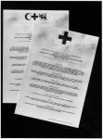 | AUSTRIA  V-P-HIST-03090  public  1965-10  © ICRC archives (ARR) /  Principes fondamentaux de la Croix-Rouge adoptés à l'unanimité par la XXème conférence internationale de la Croix-Rouge à Vienne, octobre 1965.

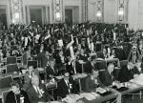 | AUSTRIA  V-P-CER-E-00837  public  1965-10  © Fédération / SCHIKOLA, Gustav  Vienna. XXth International Conference of the Red Cross. Vote during the last plenary session.  Du 27 septembre au 9 octobre 1965.

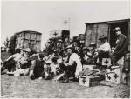 | SOUTH AFRICA  V-P-HIST-00270-53  public  © ICRC archives (ARR) /  Guerre des Boers 1899-1902. Portrait de groupe.

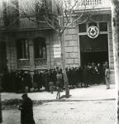 | SPAIN  V-P-HIST-01851-01  public  © ICRC /  Spanish civil war, 1936-1939. Barcelona. People queuing in front of the delegation to fill in requests.

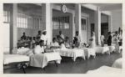 | SPAIN  V-P-HIST-01861-36A  public  1937  © CR Espagne /  Guerre civile d'Espagne 1936-1939. Madrid. Hôpital Central de la Croix-Rouge
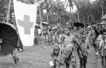 | NIGERIA  V-P-NG-N-00068-13  public  © ICRC / VATERLAUS, Max  Biafra conflict. Udo, Swedish Red Cross distribution center. Before a food distribution.
 | BIAFRA

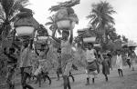 | NIGERIA  V-P-NG-N-00044-08  public  © ICRC / VATERLAUS, Max  Biafra conflict. Ogaba region. Fleeing fights, refugees flood on the road from Aba to Umahia.
 | BIAFRA
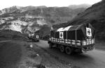 | AFGHANISTAN  V-P-AF-N-00161-21  public  1994-05-19  © ICRC / GASSMANN, Thierry  Khyber Pass. Convoi du CICR allant de Peshawar à Jalalabad.  Convoi de 22 camions transportant 14 tonnes de farine chacun.

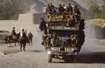 | AFGHANISTAN  V-P-AF-D-00050-05  public  1990-10  © ICRC / BREGNARD, Didier  Andarab valley. Overcrowded "bus-truck".

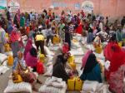 | SOMALIA  V-P-SO-E-00646  public  2012-07  © ICRC / WARSAME, Omar B.  Mogadishu. Internally displaced persons receive food from the ICRC in a joint operation with the Somali Red Crescent.  ICRC website, Operational Update, 31/08/2012  Somalis have continued to suffer the consequences of major foos insecurity and conflict over the first half of 2012. Despite the difficult situation, the ICRC has delivered food to 1,4 million people in the country since the beginning of the year.

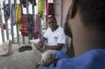 | SOMALIA  V-P-SO-E-00694  public  2014-11-05  © ICRC / YAZDI, Pedram  Bossasso prison. An ICRC delegate is conducting an interview without witness with a detainee.  These interviews allow the ICRC to assess the detention conditions. The ICRC is visiting places of detention in Somalia since 2012.
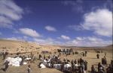 | AFGHANISTAN  V-P-AF-E-00204  public  2002-11  © ICRC / VICTOR, Stephane  Ghor province. During an ICRC food distribution.

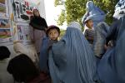 | AFGHANISTAN  V-P-AF-E-00603  public  2006-09-11  © ICRC / AHAD, Zalmaï  Kabul. Women and children attending a course on mine awareness.  ICRC provides local mine safety training classes in schools, clinics and mosques throughout Afghanistan. The training courses are provided for men, women and children alike so that Afghans have a clear knowledge of what to avoid in the field.
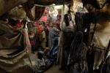 | SOMALIA  V-P-SO-E-00139  public  2006-12-03  © ICRC / SCHAEFFER, Benoît  Mogadishu. Internally displaced persons camp.  Réfugiées ou déplacées, plus de 800'000 personnes vivent dans des huttes ou des bâtiments en ruine dans la capitale. 800,000 people - refugees and displaced persons - are living in huts and ruined buildings in the capital.

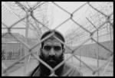 | AFGHANISTAN  V-P-AF-E-01460  public  2009-03  © ICRC/VII / NACHTWEY, James  Detainee held by the Afghan authorities.  James Nachtwey a photographié des personnes détenues par les autorités afghanes, comme les hommes figurant sur cette photo. Sasha, un interprète du CICR basé à Kaboul, l'a accompagné. Plus tard, il a parlé de ce qu'il avait appris :  " J'ai découvert que beaucoup d'entre eux avaient conservé l'estime de soi, qu'ils étaient sortis indemnes de situations très difficiles. Parfois, je me demande si j'aurais fait aussi bien qu'eux dans la même situation. Je ne sais pas comment ils ont réussi à conserver leur dignité ; c'est ce qui m'étonne le plus. "  James Nachtwey photographed detainees held by the Afghan authorities like the men in this photo. Sasha, an ICRC interpreter based in Kabul, accompanied him. Afterwards, Sasha spoke of what he had learnt:  "I discovered that many of them had held on to their sense of themselves, that they had emerged intact from some very difficult situations. Sometimes, I ask myself: 'In a situation like theirs, would I have done as well?' How they managed to preserve their dignity: this is the astonishing thing for me."

